Exercise 1

1. hf = subset(hall.fame, select=c("AB", "hits", "HR", "RBI"), subset=Hall.Fame.Membership != "not a member")
2. boxplot(lapply(hf,scale))
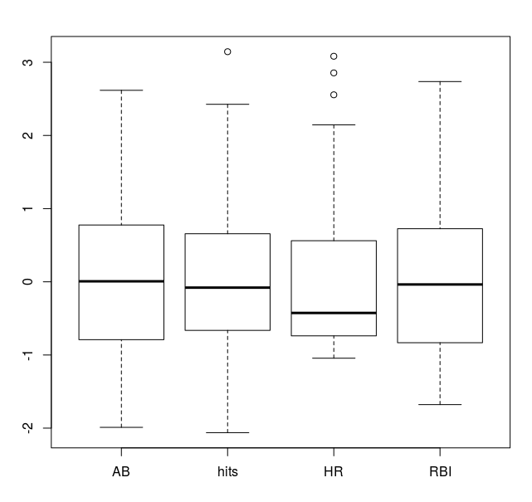

Exercise 2

1. boxplot(u2, col="red", cex.axis=0.7, height=5, varwidth=TRUE)
Rattle & Hum has the most spread. All the median are somewhat similar.
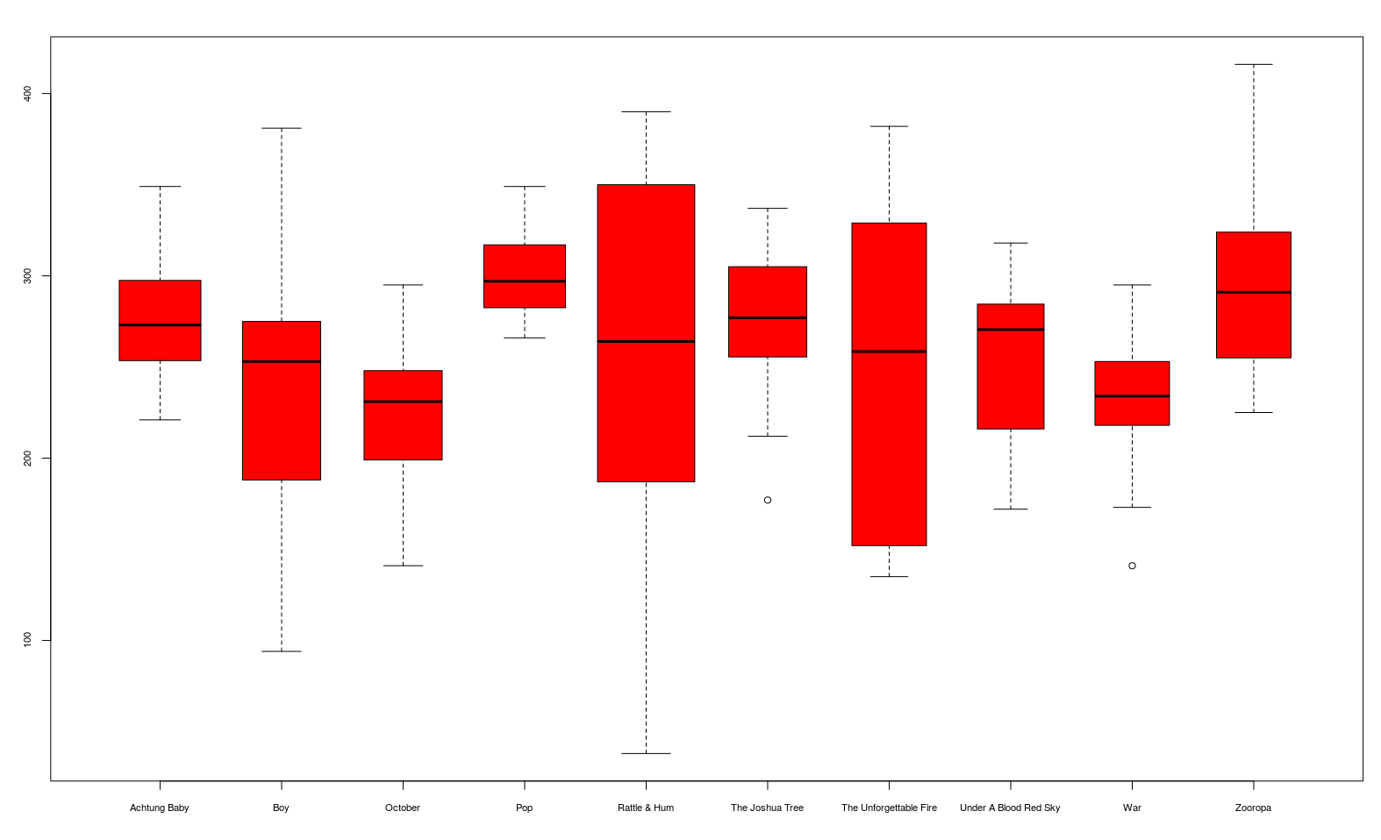
2. sapply(u2, mean)
Shortest mean = October (224.4545)
sapply(u2, median)
Yes, the results are very similar.
3. rev(sort(unlist(u2)))[1:3]
The longest 3 songs are: Lemon, Zooropa and All I Want Is You

Exercise 3

library(lattice)
data(ToothGrowth)
bwplot(len ~ factor(dose) | supp, data = ToothGrowth)
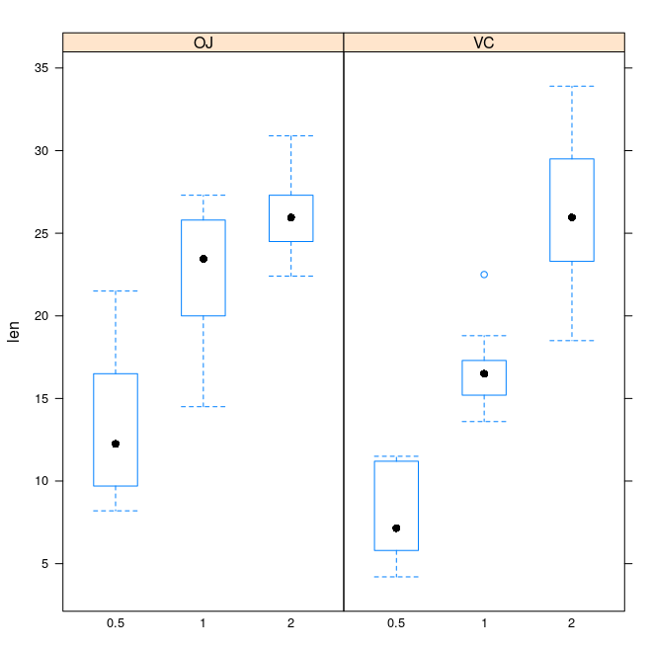

bwplot(len ~ supp | factor(dose), data = ToothGrowth)

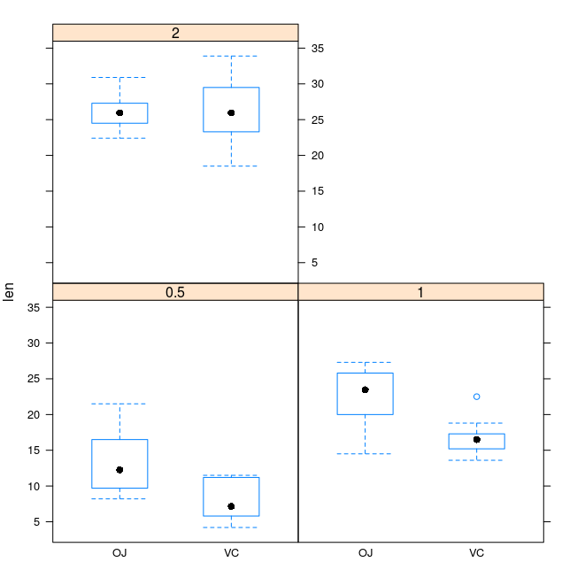

Exercise 4

xyplot(circumference ~ age | Tree, data = Orange)

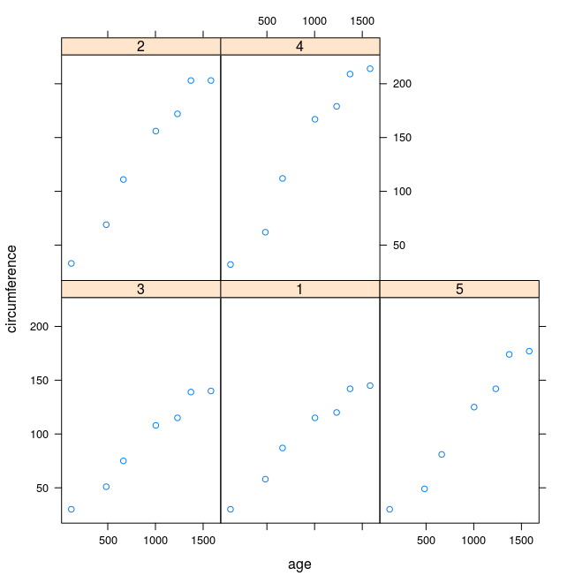
Exercise 5

P(B|A) = P(A|B)P(B) / (P(A|B)P(B)+P(A|C)P(C)) =
1*0.001 / (1*0.001+0.04995*0.999) = 0.01964..

Answer = ~1.96% chance that the person actually has a gun

Exercise 6

You swap each time to go from 1/3 to 2/3 chance to win the gold. This is because the each time a door is opened, the door you didn’t choose gets “tested” - i.e, it could have been opened to reveal a goat, but wasn’t.

